# For While Do while Break Continue Assignment

1. WAP to read a number n and to display the cumulative sum of factorial of all numbers upto n . (use for or while)

Input: 4

Ouput: 4!+3!+2!+1! = 32

1. Code

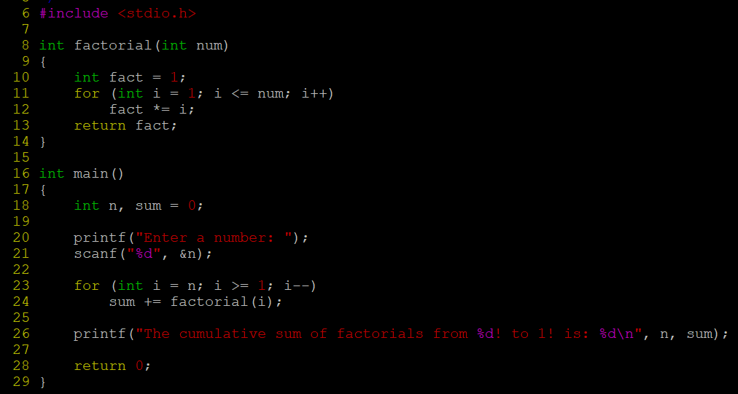

Output:

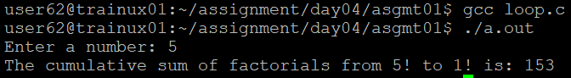

1. Write a program to accept “N” integers from the user. “N” also has to be taken from the user. Take the count of +ve numbers, -ve numbers and 0’s.

However the program should not accept a non-integer value. If a non-integer value is entered, used must be asked to re-enter.

[Hint:

* 1. Use the return value of scanf to find out whether the user has entered integer or not.
  2. You also will have to clear the input buffer before taking the next input.

For clearing the input buffer, use one of the following approaches

* while (getchar() != '\n'); // keep reading till newline and discard the characters
* scanf(“%*s”); // read and discard one string

]

1. Code:

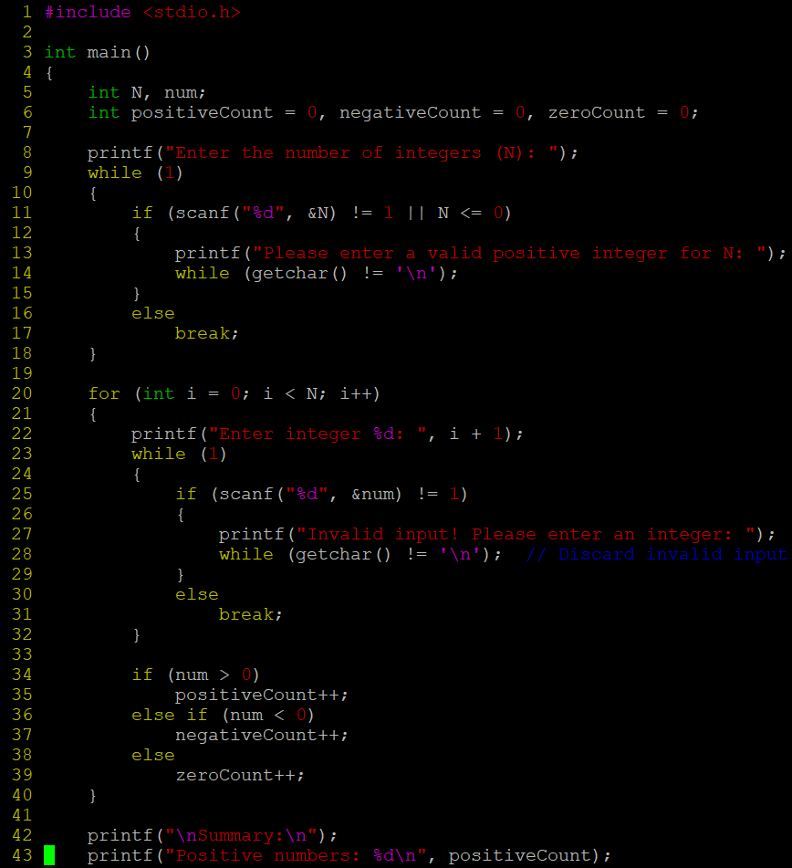

Output:

1. Write a program to continuously read a string of maximum length 80 chars, End the program if string is END, else convert to upper case, display and continue. (use while)
2. Code:

Output:

1. Refer the program “value_out_of_domain.c”. Try to run the program with a large value say 255. Check the output? Is it correct? Fix the issue observed.

What improvements do you suggest?

1. The program with int or long long int overflows for large values like 255!. To fix this, use the GMP library to handle arbitrarily large integers and compute large factorials correctly.
2. Refer the code below. It does not output anything. Fix it.

#include <stdio.h>

int main()

{

int x = 5;

while (x > 0);

{

printf( "Value of x :%d \n", x);

x--;

}

return 0;

}

1. Code:

Output:

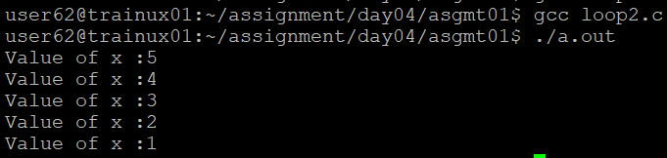

1. Analyse the code, identify the issues

#include <stdio.h>

int main()

{

float cnt = 0, num = 1000;

do

{

printf ("\n%d\n%d", num,cnt);

num /= cnt;

} while (cnt --); /* End of while */

return 0;

}

1. Code:

Output:

